PROJECT REPORT ON

GOVERNMENT ARTS AND SCIENCE COLLAGE

Submitted by

NISHA

RAGAVI

MAHA LAKSHMI

SABITHA

ANALYSING HOUSING PRICES IN METROPOLITAN

AREAS OF INDIA

1.INTRODUCTION

The dice shortage of affordable housing in Mumbai is a Result of unrealistic policies, flowed planning, and the introduction of scheme without assessing the state’s capacity to implement

The announcements of any development profects usually lead to increased land prices even before the actual development occurs, leading to a dual movement of property prices.

2. PURPOSE

2.1 Public awareness:

Their proper aims to examine the dynamic s of house prices in Metropolitan cities in an emerging economy.

The purpose of this study is to characterize the house price dynamic and the spatial heterogeneity in the dynamic.

2.2 Long term impact

Long-term fundamentals drive the Indian housing markets, where wealth parameters are stronger then supply side parameters such as construction costs or availability of financing housing priojects.

3. PROBLEM DEFINITION &DESIGN THINKING

The research methodology uses panel econometrics allowing for spatial heterogeneity, cross-sectional dependence and non-statenary data.

4. EMPATHY MAP

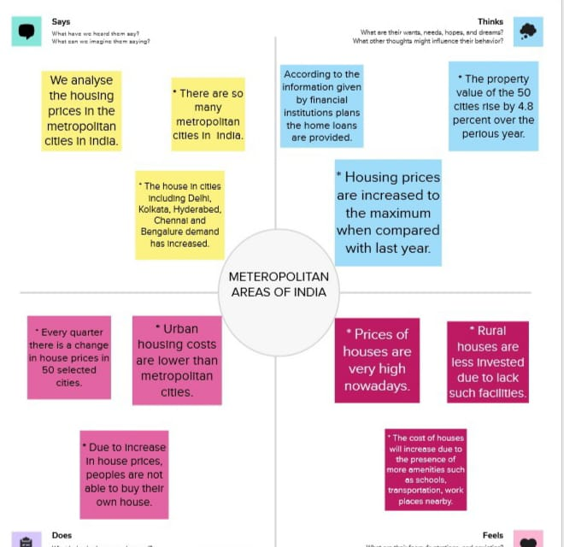

5.BRAINSTROMING MAP

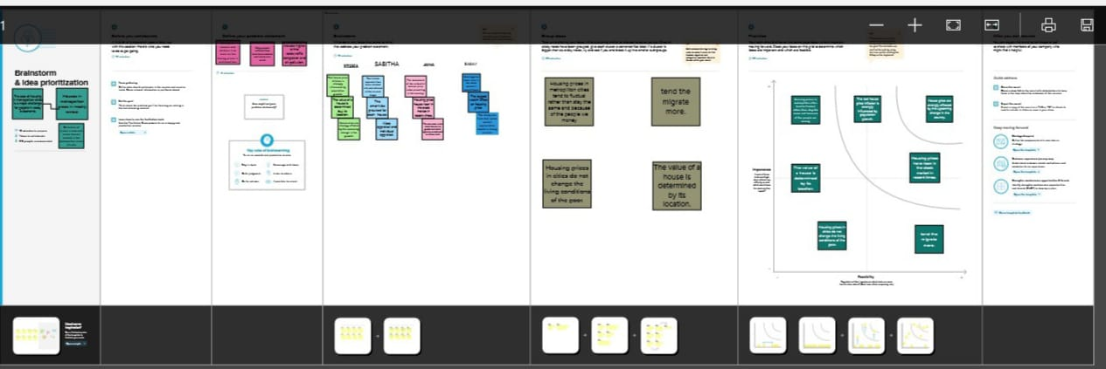

6.RESULT

6.ADVANTAGES

Metropolitan areas are the economic and cultural centres of india, and they attract a large number of people from all over the country.

This high demand for housing drives up property prices, making metropolitan areas a good investment for those looking to generate long term returns.

7.DISADVANTAGES

Those cost of living in metropolitam areas is generally higher than in other parts of the country.

This includes things like food, transportation, and housing.

8.APPLICATION

House price predication can help the developer determine the selling price of a house and can help the customer to arrange the right time to purchase a house.

Average house prices were farcast to rise 6% next year and in 2024.

9. CONCLUSION

House prices is one location in india cannot impose a competitive constaint on house prices in other location, and as such a home owner can freely set the price of his house.